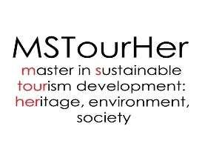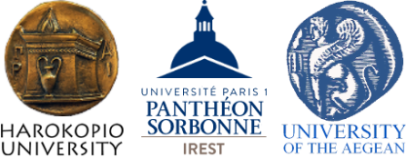

Virtual Open Day

International Master Programme "Sustainable Tourism Development: Heritage, Environment, Society"

04.05.2022
17:00  (Greek time) | Despoina Sdrali  Co-Director of the International Master Programme "Sustainable Tourism Development: Heritage, Environment, Society", Associate Professor, Harokopio University of Athens, Greece
17:15 | Francesca Cominelli  Co-Director of the International Master Programme "Sustainable Tourism Development: Heritage, Environment, Society", Associate Professor, Université Paris 1 Panthéon-Sorbonne, France
17:30 | Paris Tsartas  Professor of Tourism Development, Harokopio University of Athens, Greece
17:45 | Discussion

