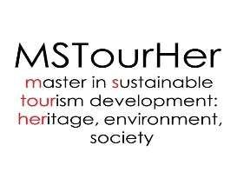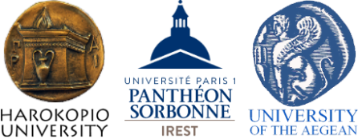

Virtual Open Day

04.05.2022

International Master Programme

"Sustainable Tourism Development: Heritage, Environment, Society"

The International Master Programme (MSc) “Sustainable Tourism Development: Heritage, Environment, Society” is implemented through the pioneer cooperation of three Universities, the Harokopio University of Athens (Department of Economics and Sustainable Development, Department of Geography, Department of Informatics and Telematics), the University of Paris 1 – Panthéon-Sorbonne (IREST – Institute for Research and Higher Studies in Tourism) and the University of the Aegean (Department of Business Administration). Courses take place at Harokopio University of Athens’ excellent premises.

The International Master Programme and the Career Office of Harokopio University of Athens are holding a Virtual Open Day on Wednesday 04/05/2022. The event is addressed to prospective students who consider applying to the Programme, which launches its 5th year of operation and invites those interested to submit their candidacy for the academic year 2022-2023.
We are delighted to extend a very warm invitation to join us on Wednesday, May 4th from 17:00 (Greek time) for our Virtual Open Day. Our on-line event will give you the opportunity to be informed about the Programme by faculty members.
Book your place today and we will send you information about how to join the event on-line and get the most out of your visit. Register here.

in case that physical presence is permitted.

