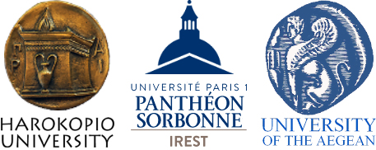
International Master Program (MSc) in
“SUSTAINABLE TOURISM DEVELOPMENT: HERITAGE, ENVIRONMENT, SOCIETY”

Athens, 28.09.2020
Protocol Number: 88766

Extension of application deadline for admission to the
Postgraduate Program “Sustainable Tourism Development: Heritage, Environment, Society”
We would like to inform all those interested in submitting an application for admission to the Program”Sustainable Tourism Development: Heritage, Environment, Society” that the deadline for submitting candidacies is extended until 20/10/2020.

All interested parties are strongly advised to submit electronically the application form along with the supporting documents until 20.10.2020 through the following online application portal: https://application.hua.gr/

It is reminded that for this Master’s program may apply graduates from all Greek Universities’ departments, graduates from foreign Universities or equivalent recognized foreign institutions, as well as graduates of the Greek Technical Institutions.

The maximum number of admissions is 60.

The Master’s Program is self-financed and the total cost for each participant amounts to 4.500,00 €.
More information can be found in the original text of the announcement by following the link: https://www.hua.gr/files/2020/MSTourHer2020.pdf
For any further clarification, please contact us at 210-9549107 or e-mail us at tourher@hua.gr.
The Director
Professor Paris Tsartas

